Uniqueness Check

Definition
# Source: AI Source: Provided by: [Data Path: Persons Table -> ID Column: 1, Name_En Column: Motasem Essam] -> From: [ChatGPT] on [12/10/2025]
Uniqueness Check ensures that each data entry is distinct and does not duplicate existing records in a dataset or database.
- It prevents duplicate entries, which could cause errors, miscalculations, or inconsistencies.
- Often applied to primary keys, ID numbers, email addresses, or unique codes.

Key idea:
# Source: AI Source: Provided by: [Data Path: Persons Table -> ID Column: 1, Name_En Column: Motasem Essam] -> From: [ChatGPT] on [12/10/2025]
It’s like making sure each student ID or employee number appears only once in the system.

Characteristics
# Source: AI Source: Provided by: [Data Path: Persons Table -> ID Column: 1, Name_En Column: Motasem Essam] -> From: [ChatGPT] on [12/10/2025]
- Validates that no two records share the same unique identifier.
- Often applied to fields designated as primary keys in databases.
- Helps maintain data integrity and accuracy.
- Can be used in databases, spreadsheets, and registration forms.

Examples
# Source: AI Source: Provided by: [Data Path: Persons Table -> ID Column: 1, Name_En Column: Motasem Essam] -> From: [ChatGPT] on [12/10/2025]
- Student ID
- ID: 101 ✅ (unique)
- ID: 102 ✅ (unique)
- ID: 101 ❌ (duplicate, not allowed)
- Email Addresses
- Email: ali@example.com ✅
- Email: sara@example.com ✅
- Email: ali@example.com ❌ (duplicate)
- Product Code
- Product Code: P001 ✅
- Product Code: P002 ✅
- Product Code: P001 ❌ (duplicate entry, not allowed)
- Social Security Number (SSN)
- SSN: 123-45-6789 ✅
- SSN: 987-65-4321 ✅
- SSN: 123-45-6789 ❌ (duplicate, violates uniqueness)

Advantages
# Source: AI Source: Provided by: [Data Path: Persons Table -> ID Column: 1, Name_En Column: Motasem Essam] -> From: [ChatGPT] on [12/10/2025]
- Prevents duplicate records in databases or datasets.
- Ensures accuracy and integrity of data.
- Critical for identifiers like ID numbers, codes, or account numbers.
- Supports reliable reporting, analysis, and processing.

Disadvantages
# Source: AI Source: Provided by: [Data Path: Persons Table -> ID Column: 1, Name_En Column: Motasem Essam] -> From: [ChatGPT] on [12/10/2025]
- Requires proper indexing or constraints to enforce uniqueness.
- Can block valid updates if not handled carefully (e.g., reusing a retired ID).
- May slow down data entry in large datasets if uniqueness checks are frequent.

Example Section
# Source: AI Source: Provided by: [Data Path: Persons Table -> ID Column: 1, Name_En Column: Motasem Essam] -> From: [ChatGPT] on [12/10/2025]
A school database of students:
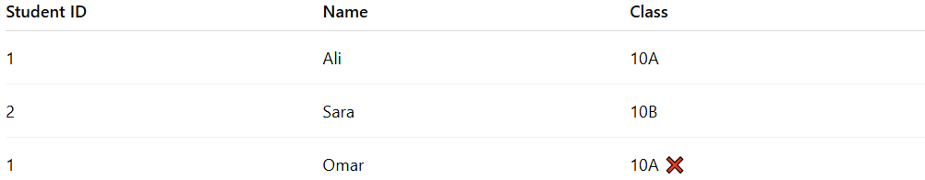
Student ID | Name | Class
1 | Ali | 10A
2 | Sara | 10B
1 | Omar | 10A ❌
- Omar’s Student ID duplicates Ali’s ID.
- The system flags the entry, preventing storage until a unique ID is assigned.

